课程编号： C0809003150

《Python程序设计》实验报告



姓名 | 刘宸绪 | 学号 |  | 20171807
班级 | 软英1701班 | 指导教师 |  | 代钰
实验名称 | python综合实验开发与总结
开设学期 | 2017-2018第2学期
开设时间 | 第1周——第8周
报告日期 | 2018年10月26日
评定成绩 |  |  | 评定人 | 代钰
评定成绩 |  |  | 评定日期 | 2018-11-1

东北大学软件学院

1. 实验目的 Aim of the Experiment
熟练运用Python列表、字典、集合、数组等数据结构以及索引和切片等查询操作解决实际问题，熟练掌握Python读写文本文件的方法，熟练使用Python数据分析库函数，了解Python程序的调试方法，运用Python编写程序解决实际应用问题。
Proficient use of Python list, dictionary, set, array and other data structures, as well as index and slicing query operations to solve practical problems, proficient grasp of Python reading and writing text files, proficient use of Python data analysis library functions, understanding of Python program debugging methods, using Python programming to solve practical problems.

实验内容与实验步骤 Content and Steps of the Experiment
实验内容：本实验主要以泰坦尼克沉船船员获救预测为背景，通过让学生使用numpy，pandas等python库完成数据读取。并通过让学生使用matplotlib库完成数据的可视化分析，在此基础上，通过让学生利用scikit-learn中的工具完成对船员获救情况预测问题的求解，并在测试数据集上对预测结果进行分析。学生在完成分析任务设计过程中可以单纯使用某一算法，也可以融合多种算法以提升预测结果的准确性。
实验步骤：
- 实验背景问题理解
- 读取泰坦尼克船员获救数据
- 利用可视化方法分析影响船员获救的特征
- 利用一种数据填充方法对缺失值进行处理
- 选择或者提取适应于分类的特征
- 构建分类模型以预测船员的获救情况
- 将train文件划分为训练数据集和测试数据集模型验证并生成预测报告，根据分类模型利用测试数据集生成验证文件并提交至kaggle网站得到预测准确率并对模型进行分析
Content of the Experiment: This experiment is based on the rescue prediction of the crew of the Titanic wreck as the background, through the use of numpy, pandas and other Python libraries to complete the data reading. And through the use of Matplotlib library to complete the visualization of data analysis, on this basis, through the use of scikit-learns in the tool to complete the seafarer rescue prediction problem, and on the test data set to analyze the prediction results. Students can either use a single algorithm or fuse multiple algorithms to improve the accuracy of the prediction results in the process of completing the analysis task design.
Steps of the Experiment:
(1) understanding of the background of the experiment
(2) reading the rescued data of the Titanic crew
(3) using visualization method to analyze the features affecting crew rescue.
(4) using a data filling method to process missing values.
(5) select or extract features suitable for classification.
(6) build a classification model to predict the crew's rescue.
(7) The train file is to be divided into training data set and test data set model to validate and generate prediction report. According to the classification model, the test data set is used to generate verification file and submitted to the kaggle website to get prediction accuracy and analyze the model.

3. 实验环境 Experiment Environment
实验中需要使用python3.X开发环境。
Python3.X development environment is needed in the experiment.

4. 实验过程与分析 Experiment Process and Analysis

4.1实验背景问题理解 Understanding the Background
In fact, in this experiment, I made two models to solve the problem. To my surprise, the model which uses easier ways to fill the missing data and build the classifier got a better accuracy at %79.425, but the more complexed one could only get %77.99.The main differences between the two are mainly in filling the missing data of age, the kinds of information used in training the model and the number of methods (algorithm) used in training the model.
In this problem, we got two .csv files which contain detailed data of the passengers in titanic with some missing data. However, only one file includes the survival data. As we all know, in that event, the elders, children and female were asked to leave first. And what’s more, the ticket fare and cabin show the rich level of the passengers. From these guesses, I decided to analyze every feature together with the survival data (in ‘train’ file) in visualization method, in order to decide which feature will be used in model building.

4.2实验数据读取 Reading the Data
First, I read ‘train’ file in, using the ‘pd.read_csv’ method. From getting the info, I found that there are missing data in ‘Age’, ‘Cabin’ and ‘Embarked’. I chose to ignore the missing ‘Embarked’ and ‘Age’ data first, but fill the ‘Cabin’ data with ‘1’ for notnull and ‘0’ for isnull.
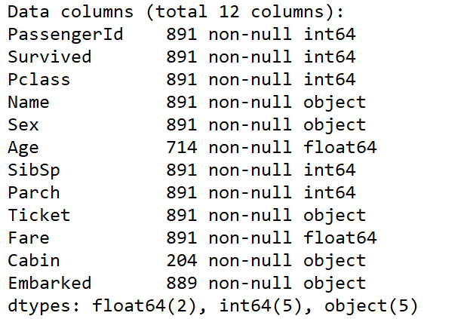

4.3 数据可视化分析 Visualized Analysis
After that, I mainly used the ‘matplotlib’ library to draw bar charts, line charts and scatters to show the dependency between each feature. And I got these.
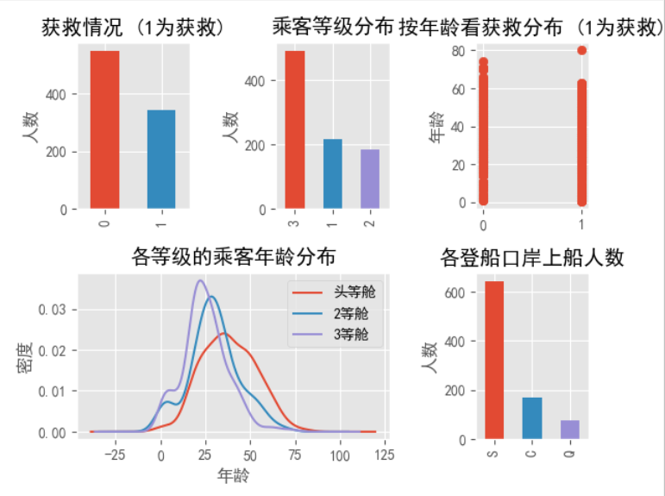
These show the number of people in different condition in every feature. People in age 65—80 were more unlikely to survive.
Then, the features together with ‘Survival’.
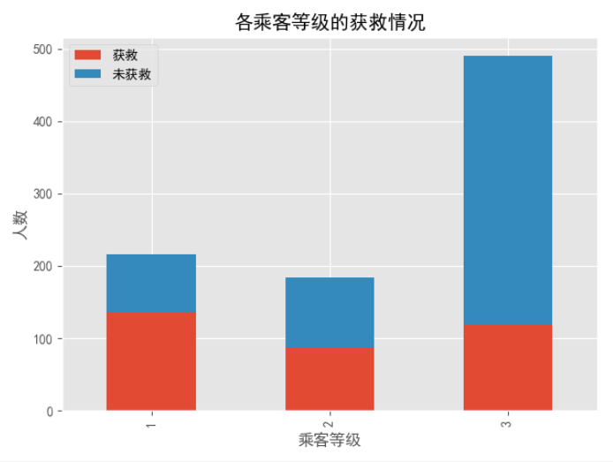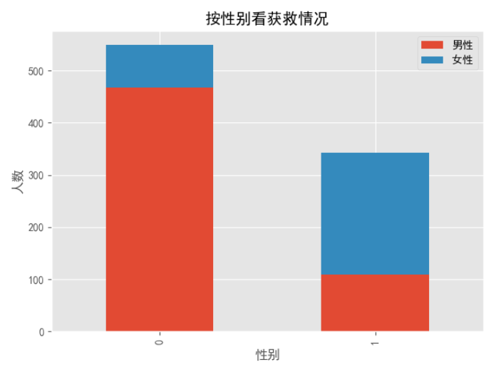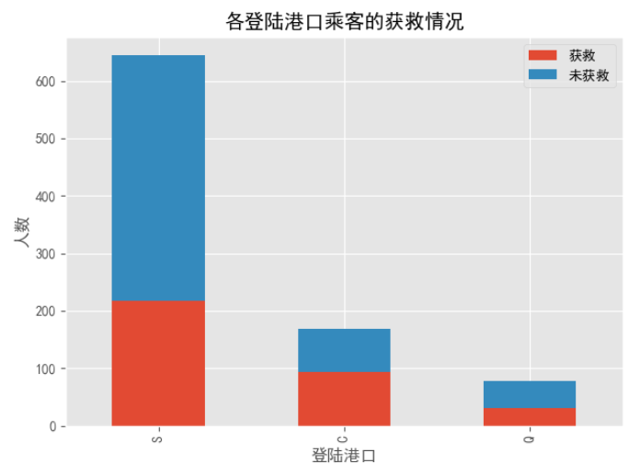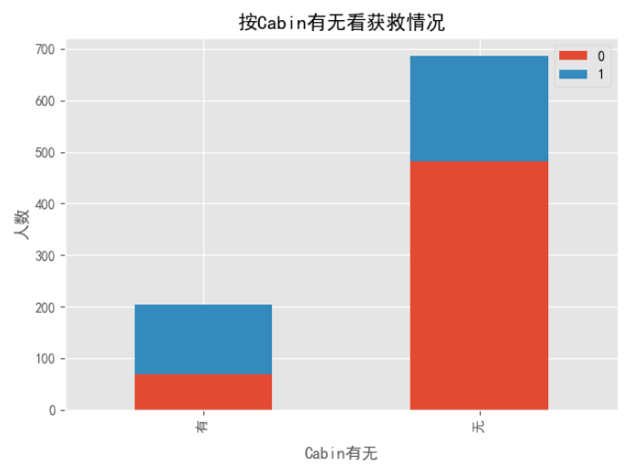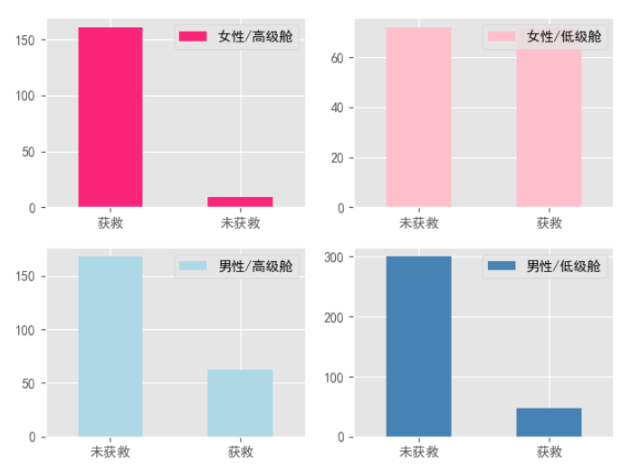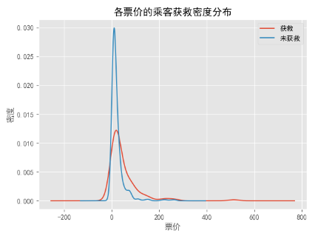
We can easily find that survival is strongly connected to ‘Sex’, ‘Pclass’, ‘Age’ and ‘Fare’. We can easily found that our guess was almost right because the women’s survival rate is obviously higher than men’s and those high class passengers were more easily to survive. I deliberately left the default value in the ‘Fare’ chart because I found it interesting that there are also some fluctuate after $200. Because of there are few people paid that high to buy a ticket, I found the survival rate really high in them. Analyzing these chart gave me a clear thought to fill the missing data and build the model.

4.4 缺失数据填充 Filling the Missing Data
I really tried hard to fill the missing data because I think the model couldn’t be very correct if I just fill the missing data with mean value and mode, especially the feature ‘Age’. In my first type, I chose all the easiest way to solve the problem, and to improve it, I added the feature ‘Title’ in it because I knew that their titles may represent different age levels. For example, the title ‘Mrs’ may consider to be above 40 years old, but the title ‘Master’ may consider to very young boys. To make it more correct, I added a new title ‘Girl’ in to represent young women with ‘Miss’ title because I found that the ‘Miss’ title has a very big variance, which means there are ‘Miss’ of very different age in the ‘Miss’ title. I also found that some of the titles are very rare, so I put them in title ‘Rareman’ and ‘Rarewoman’. The definition is on below.
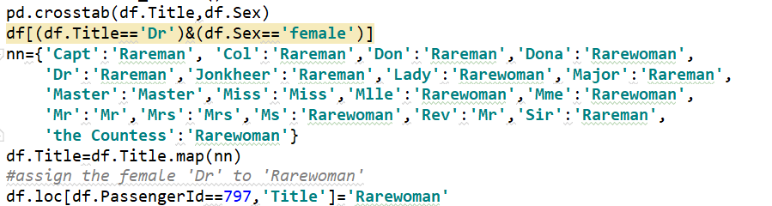
This is the statistic chart.
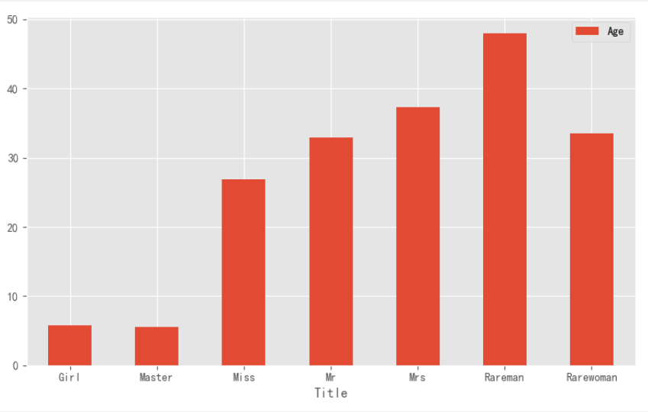
We can see that there are big differences among these titles. However, on the result, I found the easier one (just fill in the mean numbers) is better, which is a bit strange.

4.5 特征选择 Feature Selection
After analyzation, I dropped the ‘Name’, ‘PassengerID’ and ‘ticket’ feature. However, I added the ‘Namelength’ in the complexed program and I also dropped the ‘Cabin’ feature in the easier one. What’s more, I used the ‘get_dummies’ method to change ‘Sex’ and ‘Embarked’ to dummy variables, which are more convenient to operate. Then, I reduced dimensionality of ‘Age’ and ‘Fare’ data.
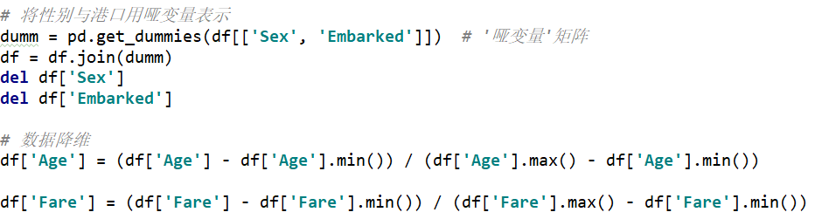

4.6 分类器构建 Build the Classifier
I separated the train data and the survived result in the proportion of 7:3 firstly.
To get the most efficient classifier, I tried many classifiers in the sklearn library, and tried to combine some of them together. Finally, after try and search, I chose 6 classifier methods in my complex one and 2 in my easy one. I tried to make them seems like voting, which means that I added the prediction of every classifier together and got the mean number and do the rounding off to get the final result. It is a rough way, but efficient. After long time of adjusting parameter, I finally got this.
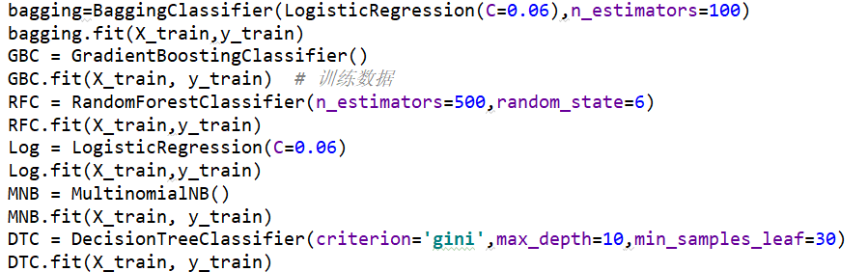
In the easier one, I only chose GradientBoostingClassifier and RandomForestClassifier.

4.7 模型验证 Validation of the Model
To do the cross validation, I chose k-fold cross validation method and set k to 10 and print the accuracy of every method. In fact, each classifier has it own ‘score’ method. In the easier one, I just used the two ‘score’ methods and get the mean number as the final accuracy.
I did the k-fold code like this:
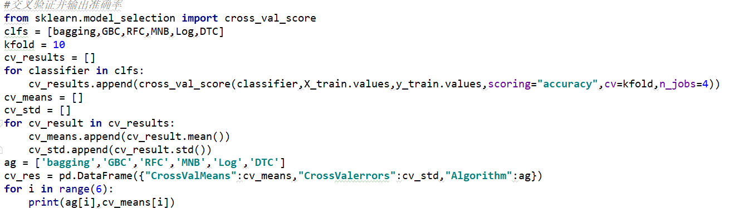

5.实验总结 Summary
主要描述实验中存在的不足，哪方面还可以进行改进和优化。不要写个人体会(Mainly describes the shortcomings of the experiment, which areas can also be improved and optimized. Don't write personal experience.)

From typing this programme and watching the rank on the website ‘Kaggle’, I really know that there is still a big gap between those top people and me. My programme still has some deficiency and still needs improvement.
The first thing I want to change is to improve the way I filled the missing data. Although I tried to fill the people’s age by reading their title, in the deeper mode, I also used the mean numbers. For I think, we could use some more correct way to fill the missing data. For example, Gaussian distribution or Random Forest. I think using these methods would increase the accuracy compares to the mean numbers.
Next, about adjusting parameter. The way I adjusted those parameters is to search on the internet to get the kinds of parameter, the most common value of those parameters, and have a range of try to get my best answer. I believe there must be some more efficient and correct way to get the values of parameter which make the result most correct. For example, I found a method called ‘gridsearch’, which could help us to get the best parameter value.
Then, to integration those classifier methods. In my program, I only used the mean numbers and rounding off to get the final result, which is a really rough voting way. However, I think, to use an integration method (eg: voting or bagging method) to combine those classifier method should be a more efficient way to give a correct result.
Finally, because of the reason about the integration arithmetic problem I mentioned before, getting the final validation and the prediction of accuracy becomes a problem, too. What I did is only add all those value produced by the ‘score’ method and get the mean number, but if I get a integration object, I would get the prediction of accuracy more easier and more accurate.
Although there are still many disadvantages in my programme, I think I have done my best to do that. And at the same time, I studied a lot about Python. I’m looking forward to study deeper about this experiment, and glad to face the next challenge!

附录：

《Python程序设计》实验成绩评定表


Factors | 具 体 要 求 | Mark | Score
Basic Content | The process is implemented with python and can achieve a result. | 40 | 40
Performance | The model has a better accuracy. | 20 | 20
Improvement | Use a better algorithm to solve some typical problem such as missing data, feature extraction and model fusion. | 20 | 20
Report | Better express the main idea of the solution with appropriate (Not too many and not too few) figures and codes. | 20 | 20
Total |  |  | 100

